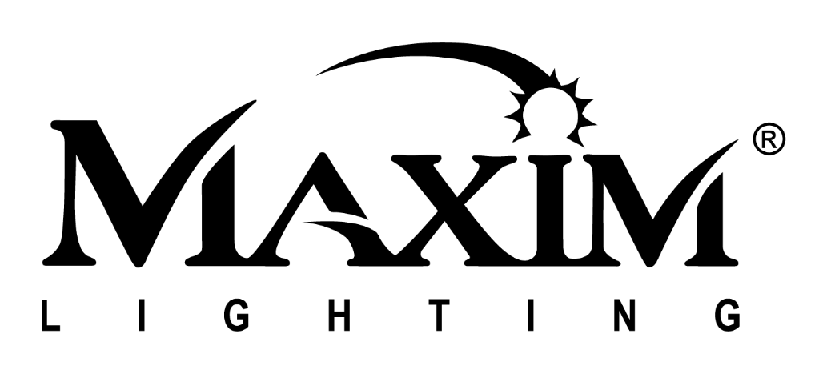
WESTERN DISTRIBUTION CENTER
(HEADQUARTER)
253 NORTH VINELAND AVE
CITY OF INDUSTRY, CA 91746

EASTERN DISTRIBUTION CENTER
4200 SHIRLEY DR.
ATLANTA, GA 3033

P. 626.956.4200
F. 626.956.4225

maximlighting.com
Maximize Your Marketing with the Right Influencers
Influencer marketing has quickly become the top marketing tool for online businesses to grow and reach their ideal targeted audiences. As consumers become more aware and averse to traditional marketing, influencers have stepped up to fill that need. Because influencers create and share on social media, their posts, feel like a personal story. Because they live on social media they have created a family of like-minded followers. They have real connections, conversations, insight, and pull with their “family.” This type of marketing feels more like a word of mouth referral as opposed to pushing ads with unreliable persuasive content. When an influencer suggests a product they are validating the authenticity of that product.
This January, Maxim Group Co. has partnered with 3 influencers to help fulfill our vision of knocking down the perceived barrier between brand and audience. These influencers are vital in promoting our brand as they are no strangers to Maxim. Instead, they were already customers and fans of Maxim so their endorsement of our products is that much more genuine. They sought us out because of their love of our brand and products. We are proud to announce our collaborations with @renaenaa, @blankslatereno, and our new Maxim Glam Ambassador @boldandgolddecor.
@Blankslatereno is a Dallas based renovation duo of married couple Chayce and Hannah. Chayce handles all of the contract work while Hannah takes care of the home design element. @Renaenaa shares phenomenal snapshots of her home and DIY projects that she creates on a budget. @Boldandgolddecor is an interior designer with a flair for the lavish and glamorous that she loves sharing with her followers.
With three distinct styles, each influencer has carved out a niche of devoted fans and followers that share their love of design. The influencers in turn interact with and establish a real connection with their followers. This niche fan base feels a more personal connection to the influencer, developing a loyalty to them. Since our influencer partners are such big fans of Maxim, they are also going to be in charge of designing vignettes for our upcoming Dallas Show in 2020, furthering the relationship between brand and partner.
When done correctly, an influencer campaign can net 11x return on investment. Influencer marketing has surpassed traditional email marketing, along with paid and organic search results, and is predicted to become a $10 billion-dollar industry. The right influencer has to incorporate 3 major fields, a trusted opinion; their followers need to trust their taste. Additionally, they need a believable business model, the products being promoted need to be believable for the influencer to be using/selling. Finally, a great influencer needs to be able to promote this as a friend giving a trusted opinion versus a stranger trying to make a sale.
Consumers place a lot of trust in influencers they follow on social media, this evidence crosses all age, income, and race demographics. We have worked extensively with social media influencers in the past and are excited about our upcoming collaborations in the works with our newest influencers and ambassadors.

